USER MANUAL

REQUIREMENTS:
- Hardware Requirements:
- CPU: 2 x 64-bit 2.8 GHz 8.00 GT/s CPUs
- RAM: 32 GB (or 16 GB of 1600 MHz DDR3 RAM)
- Storage: 300 GB. (600 GB for air-gapped deployments.) Additional space recommended if the repository will be used to store packages built by the customer. With an empty repository, a base install requires 2 GB.
- Internet access to download the files from Anaconda Cloud or a USB drive containing all of the files you need with alternate instructions for air gapped installations.

The following are minimum specifications for the master and worker nodes.

Master node | Minimum
CPU | 32 cores
RAM | 64GB
Disk space in /opt/anaconda | 500GB
Disk space in /var/lib/gravity | 300GB
Disk space in /tmp or $TMPDIR | 50GB
Worker nodes | Minimum
CPU | 16 cores
RAM | 64GB
Disk space in /var/lib/gravity | 300GB
Disk space in /tmp or $TMPDIR | 50GB

- Operating system requirements

- Anaconda Enterprise cannot be installed with heterogeneous versions in the same cluster. Before installing, verify that all cluster nodes are operating the same version of the OS.
- Anaconda Enterprise currently supports the following Linux versions:
- RHEL/CentOS 7.2, 7.3, 7.4, 7.5, 7.6, 7.7, 8.0
- Ubuntu 16.04
- SUSE 12 SP2, 12 SP3
- Windows 7 and above.

- Other Requirements
- License file provided to you by Anaconda at the time of purchase
- Installation tokens for binstar and anaconda-server channels provided by Anaconda at the time of purchase. Not applicable for air gapped installs.
- Optional: Your Anaconda Cloud (:: Anaconda Cloud) account credentials. Not applicable for air gapped installs.

Steps to open and execute Python program in Windows OS –

Step 1:Search for Spyder(Anaconda 3) application from the search bar and open it.

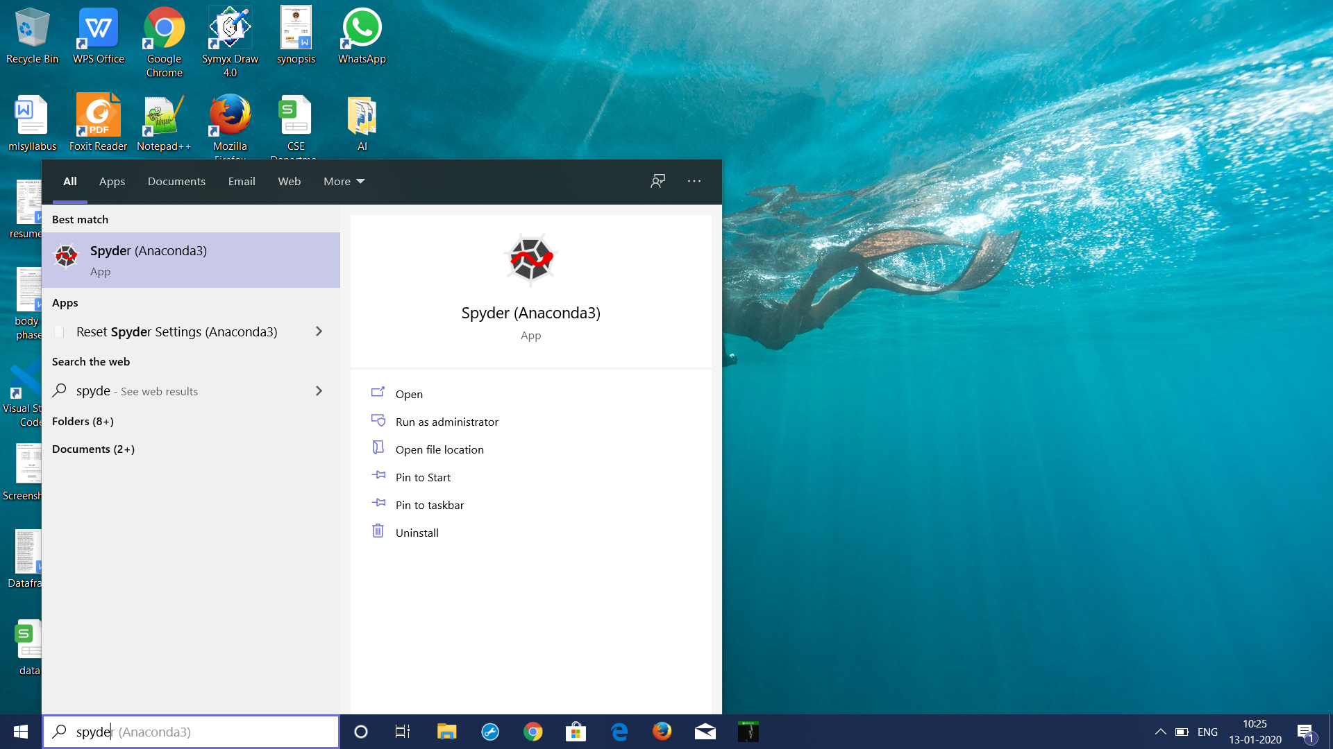

Step 2: Open a new file and start typing your python program.

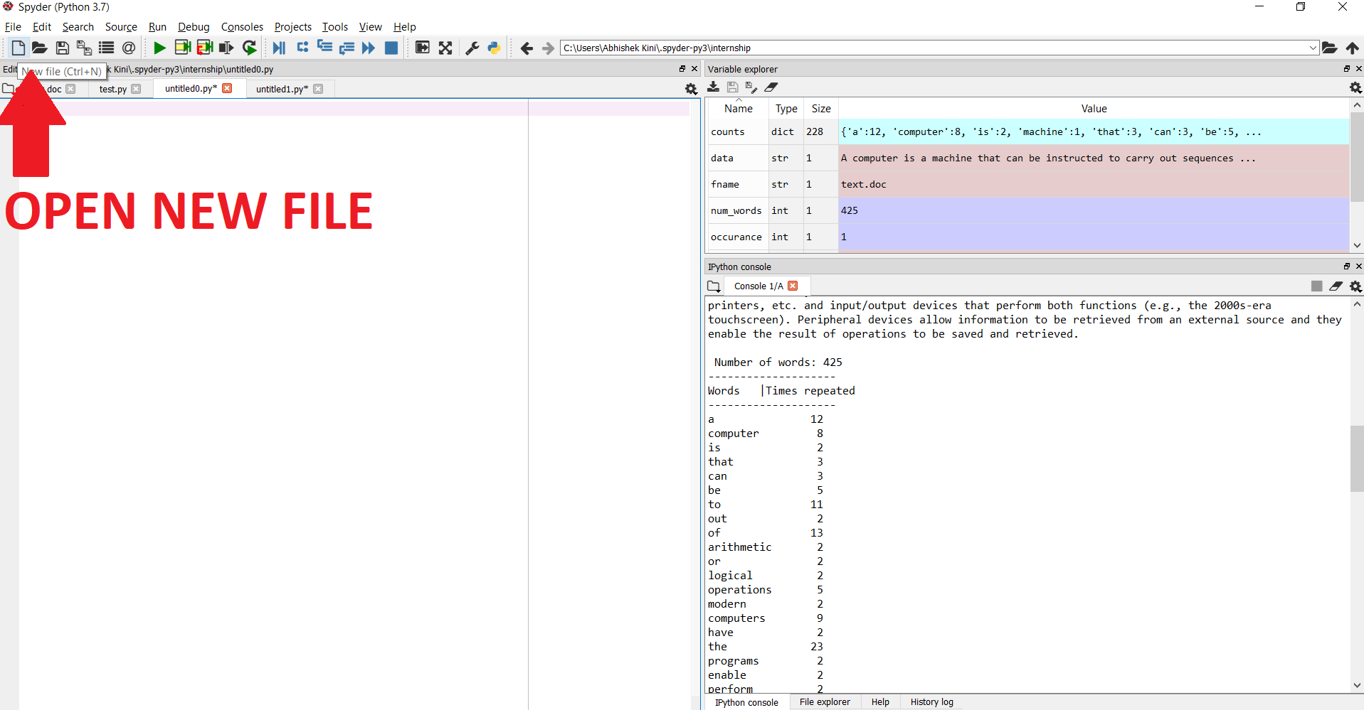

Step 3: Copy and paste the python program.
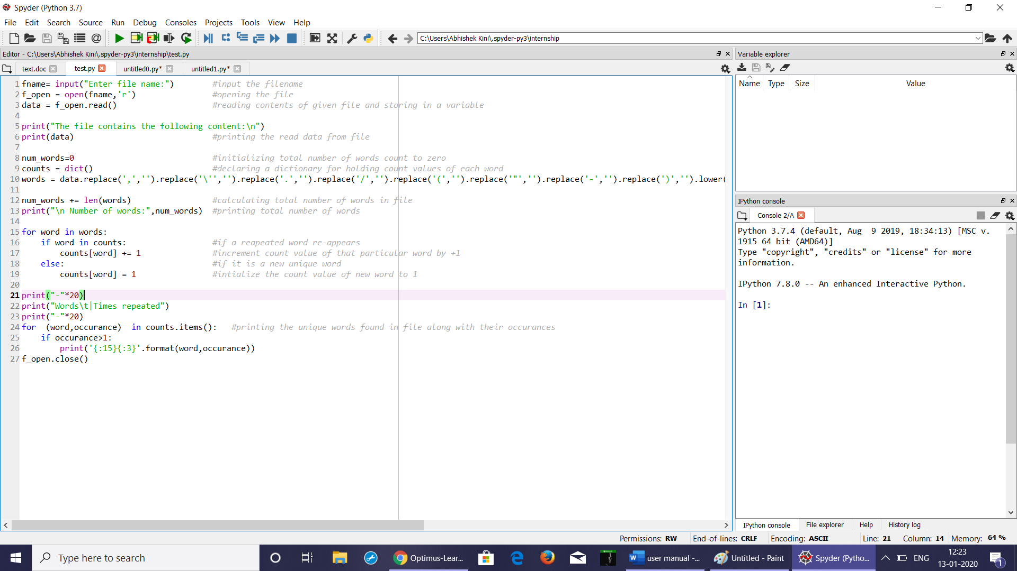

Step 4: Save the program in the present working directory as a python file.

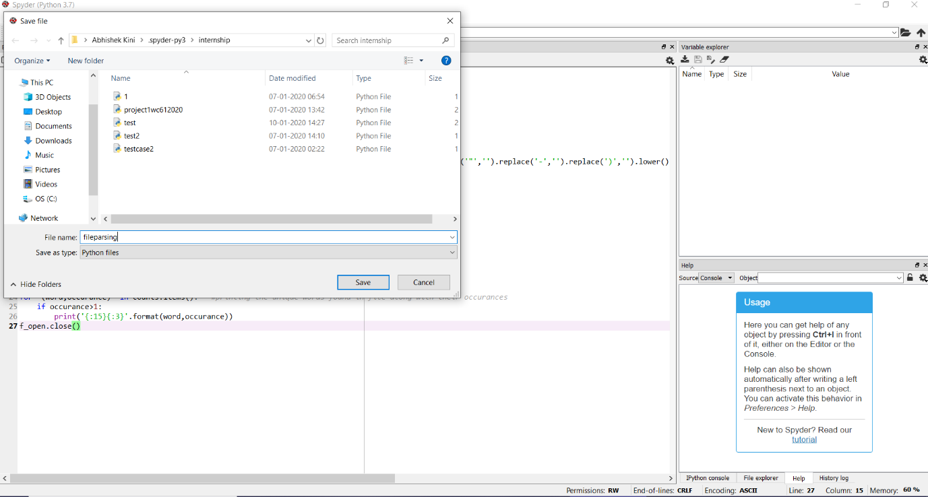

Step 5: Create a sample text file and save it as a .txt file in the same present working directory.

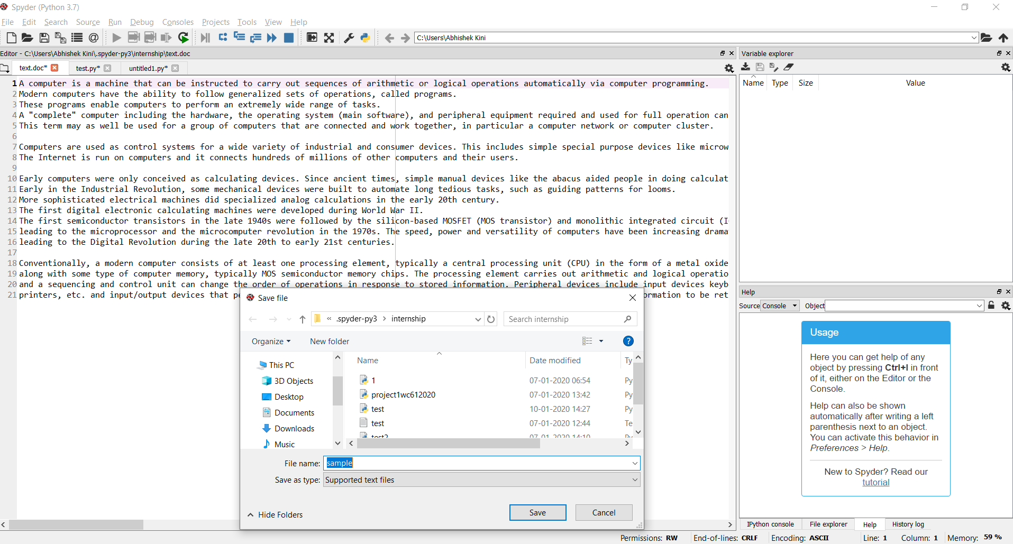

Step 6: Run the python program using the run button.
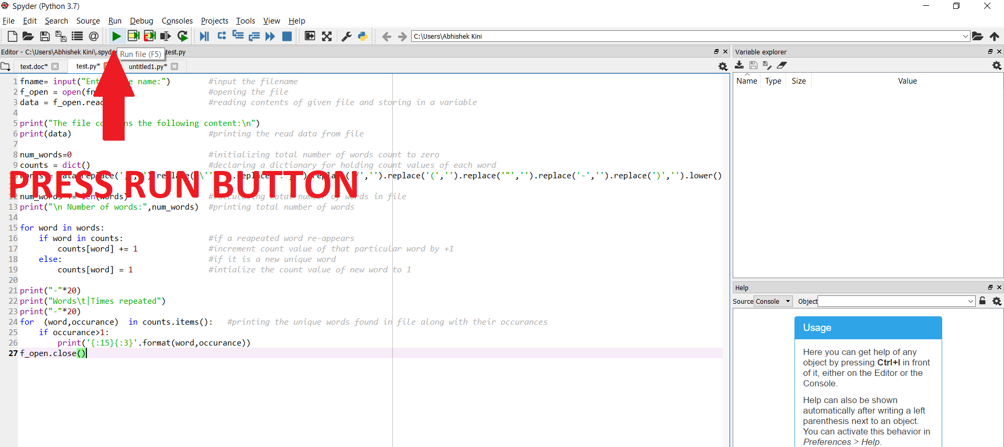

Step 7: Enter the text file name and the following output will be seen as below.

